

**CRESCENDO INTERNATIONAL COLLEGE**

**DIPLOMA IN COMPUTER SCIENCE**

**TUTORIAL**

**SEMESTER APRIL 2024**

**CHAPTER 2: INTRODUCTION TO OBJECT-ORIENTED PROGRAMMING (OOP)**

Draw UML class diagrams, then identify attributes, behavior, and the states for the following:

1. A class called "Library" with a collection of books and methods to add and remove books.

|  |
| --- |
| library |
| -Arraylist(book):string  -Librarian:string |
| +addBook():string  +removebook ():string |

1. A class called "Inventory" with a collection of products and methods to add and remove products, and to check for low inventory.

|  |
| --- |
| Inventory |
| -arraylist<product>:string |
| +addproducts(string):void  +removeproducts(string):void  +checkproducts(string):void |

1. A class called "Shape" with abstract methods for calculating area and perimeter, and subclasses for "Rectangle", "Circle", and "Triangle"

|  |
| --- |
| shape |
| +calculaterectangle():float  +calculateperimeter():float |
| Rectangle  -width  -height  +area():float  +perimeter():float  Circle  -radius  +area():float  +perimeter():float  Triangle  -attributes: base, height  +area():float  +perimeter():float |

1. A class called "Airplane" with a flight number, destination, and departure time attributes, and methods to check flight status and delay.

|  |
| --- |
| airplane |
| +Flight number: int  +Destination: string  +Departure time: int |
| +checkfilght():void  +checkdelay():void |

1. A class called "Book" with attributes for title, author, and ISBN, and methods to add and remove books from a collection.

Sample UML Class Diagram

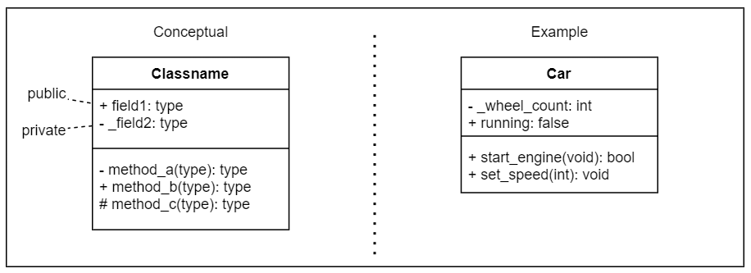

|  |
| --- |
| Book |
| Title:string  Author:string  ISBN:string |
| +addbook(string):void  +removebook(string):void  +checkbook(string):void |